DEPRESSIVE SYMPTOM TRAJECTORIES
Modeling Depression Trajectories After Detoxification
A Longitudinal Mixed-Effects Analysis of the HELP Study

Prepared by Manpreet Singh

Overview
I set out to understand how depressive symptoms change over the two years following detoxification, and whether that recovery pattern differs by baseline substance, housing status, or treatment assignment. This report walks through the dataset I used, how I prepared it, how I chose the statistical model, what I found, and what I take away from it.
The outcome throughout is CESD (Center for Epidemiologic Studies Depression scale, 0–60, higher scores meaning more symptoms), measured at baseline and every six months for twenty-four months.

Dataset
I used the HELPfull dataset from the HELP (Health Evaluation and Linkage to Primary care) study, which follows a cohort of people through detoxification with repeated interviews over time.
- Design: approximately 470 subjects, interviewed at baseline and every 6 months through 24 months (5 waves total: 0, 6, 12, 18, 24), one row per subject per wave, about 1,470 rows in all.
- Outcome: CESD score, 0–60, higher meaning more depressive symptoms.
- Predictors: time since baseline, primary substance (alcohol / cocaine / heroin), housing status (re-asked every wave), treatment/linkage-to-care arm, and age.
- A data quirk I had to work around: substance and age are only ever recorded at the baseline interview — every follow-up row has them coded as missing, because they are respondent characteristics collected once rather than repeated-measures items.

Data Preparation

Cleaning
Because substance and age are only captured at baseline, using them as-is would have left both columns missing on roughly 69% of rows — every wave after the first. Any model built on them would then have silently dropped those rows, and not at random: it would have kept whoever happened to stay in the study longest. I carried each subject's baseline value forward through their later waves (and backward for the one person whose baseline row was itself missing), which recovered 1,002 of 1,472 rows. I also range-checked cesd (0–60) and checked for duplicate subject-wave rows; neither turned up problems.

Missingness
The outcome itself, cesd, is missing on about 0.6% of rows — nine values, concentrated at the later waves. I checked whether missingness at one wave relates to the observed score at the previous wave, and it does: people with higher (worse) symptoms at a given wave were somewhat more likely to be missing at the next one. That rules out data missing completely at random, but is consistent with data missing at random — conditional on what I've already observed.
That distinction mattered for how I proceeded: because the mechanism looks like MAR rather than MCAR, I used a likelihood-based linear mixed model fit on all available observations as my primary analysis, rather than restricting to complete cases. I then ran multiple imputation and a completers-only refit afterward as sensitivity checks, to make sure my conclusions didn't depend on that choice.

How I Chose the Model
I built up to the final model in three deliberate steps, checking each one before moving to the next.
- Step 1 — unconditional means model (cesd ~ 1 + (1 | id)), fit purely to get the intraclass correlation. It came out to 0.424, meaning about 42% of the total variance in CESD scores sits between subjects rather than within them over time. That confirmed I couldn't treat these as independent observations — ordinary linear regression would have been the wrong tool.
- Step 2 — a random-intercept model adjusting for time, substance, age, housing, and treatment, giving each subject their own baseline level.
- Step 3 — a random-slope model, letting each subject's rate of change vary too, not just their starting point. A likelihood-ratio test comparing the two, together with how visibly the individual trajectories fanned out in my plots, both supported the richer model — people differ meaningfully in how fast they improve, not only in where they start.
The random-slope model is what I report as the primary result: a linear mixed-effects model (lme4::lmer, fit by REML with Satterthwaite-approximated p-values), using every available observation under the MAR assumption rather than only complete cases.

Results
The results matched what I expected going in, which gave me confidence the analysis is internally consistent.
Effect | Estimate | Notes
ICC (unconditional model) | 0.424 | About 42% of variance is between-subject
Time (per month) | −0.47 to −0.48 CESD points | ~11–12 point decline over 24 months; p < .001
Homeless status | +4.53 CESD points | Persistently higher symptoms; p < .001
Cocaine vs. alcohol (baseline) | −3.51 CESD points | p = .013; heroin not distinguishable from alcohol
Treatment arm | Not significant | p = .57 — no detectable effect on level or trajectory
Age | Not significant | p = .78
Time × substance interaction | Not significant | Rate of improvement is similar across substances

In plain terms: depressive symptoms declined steadily over the two years after detox, by roughly half a point per month. People varied meaningfully both in where they started and in how quickly they improved, which is exactly what justified the random-slope model. Housing instability was the strongest and most consistent factor in the data — homeless participants carried a persistent, multi-point disadvantage on the CESD scale that neither treatment assignment nor substance type explained away. Treatment arm itself showed no detectable effect on either starting severity or the rate of change.

Key Figures
Plotting every subject's raw trajectory shows them fanning out around a declining mean — some flat, some steeply improving, a few getting worse — which is the visual evidence behind letting each person have their own slope rather than just their own starting level.
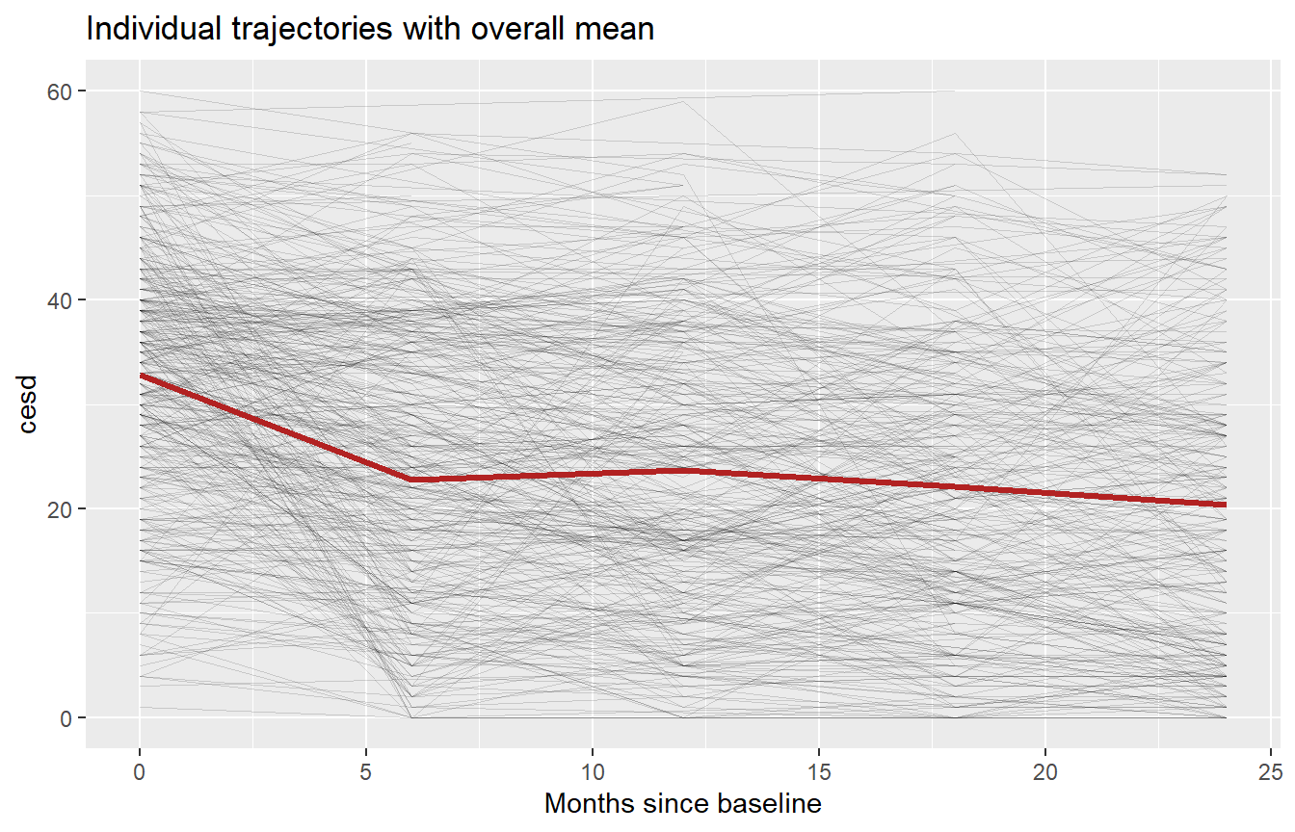
Figure 1. Individual CESD trajectories with the overall mean.
Splitting the same trajectories by primary substance, the decline shows up in all three groups at roughly the same rate — the groups differ more in where they start than in how fast they improve.
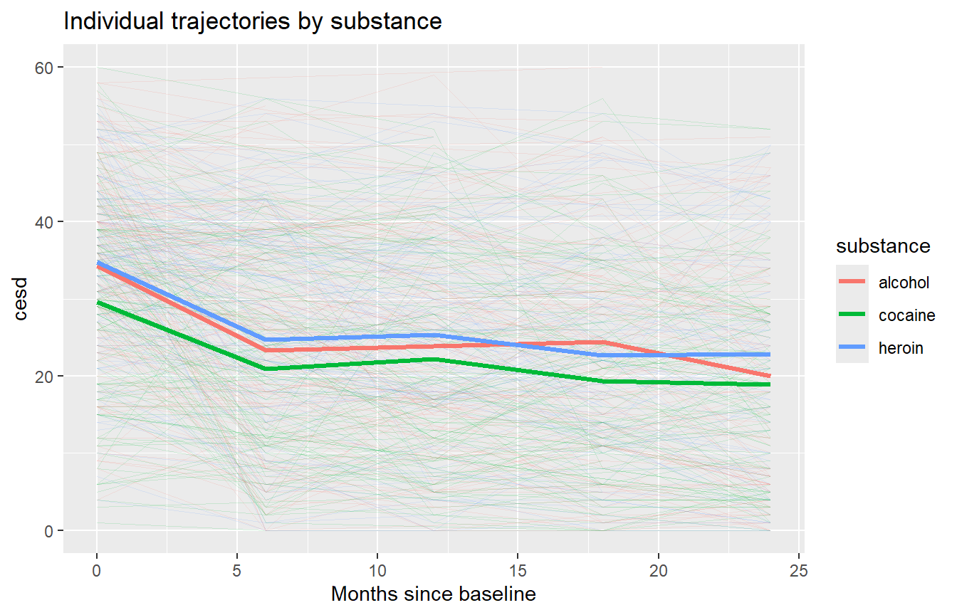
Figure 2. Trajectories by primary substance.
The model's own predicted trajectories make that pattern explicit: the cocaine group starts lower, alcohol and heroin track closely together, and all three groups decline at a similar rate over the follow-up period.
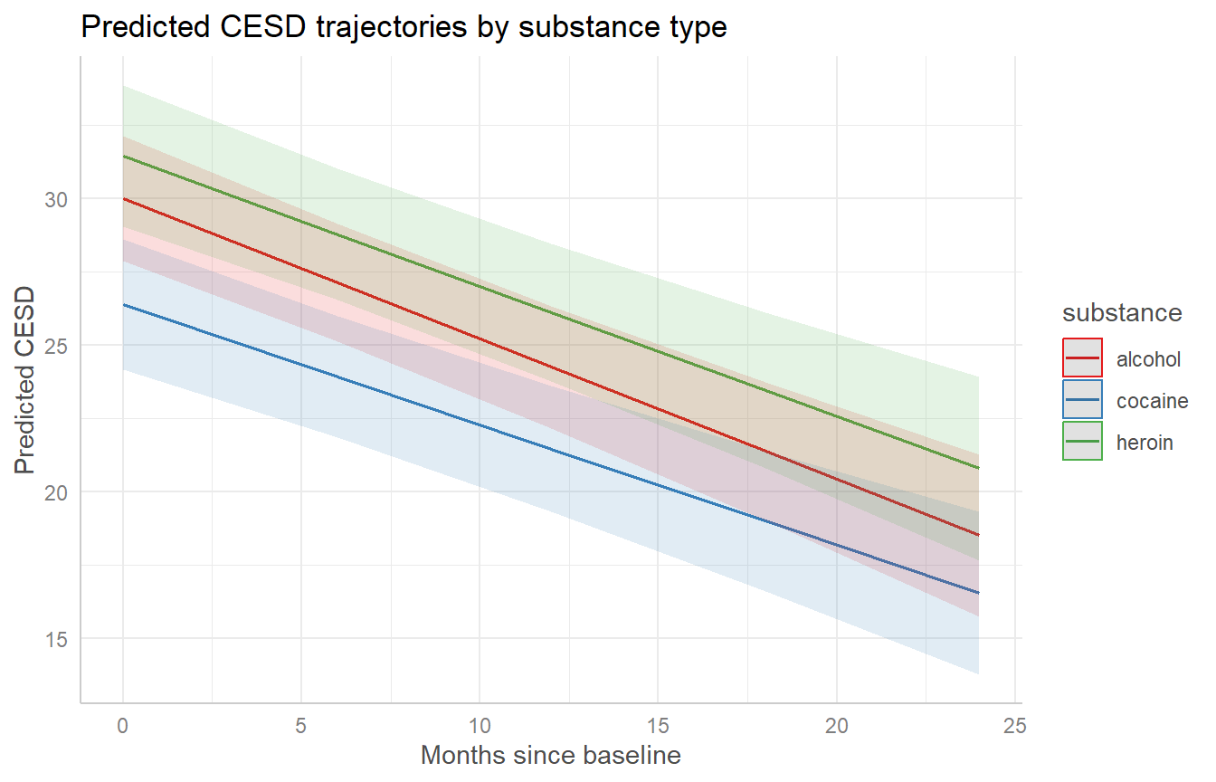
Figure 3. Model-predicted CESD trajectories by substance, with 95% confidence bands.
Finally, the full diagnostic panel for the final model — covering residuals, linearity, homogeneity of variance, influential observations, collinearity, and normality — shows nothing disqualifying, though I discuss one real caveat about residual fit in the Conclusion.
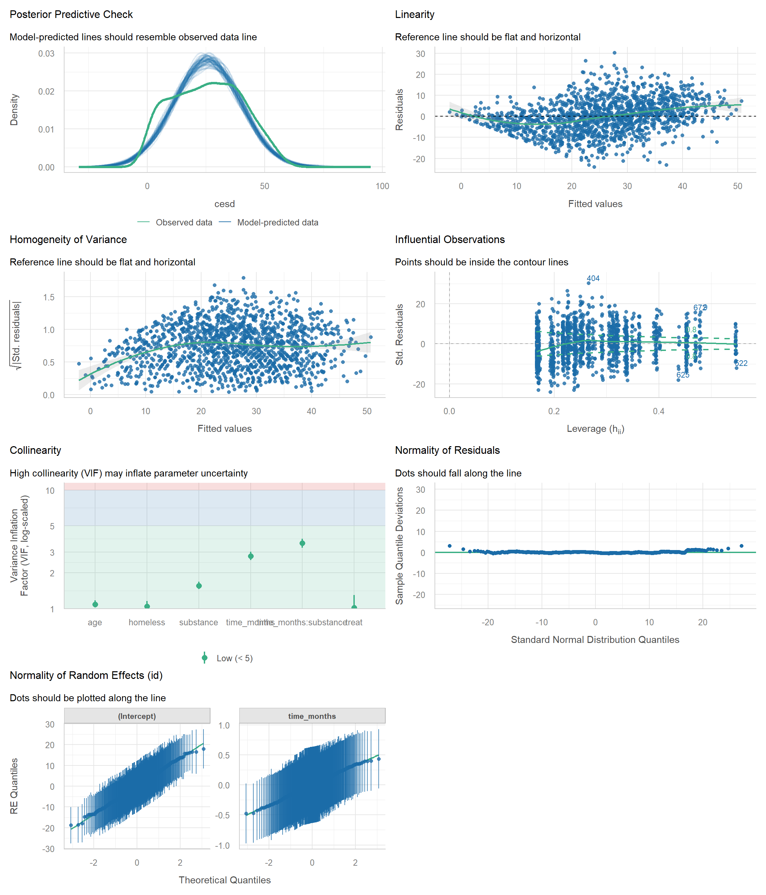
Figure 4. Full model diagnostic panel for the final model.

Sensitivity Checks
I didn't stop at a single model fit — I re-checked the main conclusions three separate ways.
- Completers-only vs. full sample: restricting to the roughly 100 subjects with all five waves observed, the time and housing effects stayed consistent in direction and significance compared to the full ~470-subject sample, as expected under MAR.
- Multiple imputation: with under 1% of cells missing once the baseline carry-forward was applied, imputed estimates came out nearly identical to the complete-case estimates.
- Simulated residual diagnostics (DHARMa): these flagged real deviations from the model's Gaussian assumption — the Kolmogorov–Smirnov, dispersion, and outlier tests were all significant. That's expected for a 0–60-bounded outcome modeled with a linear mixed model, but it's a genuine limitation worth naming rather than glossing over.

Conclusion
Depressive symptoms declined steadily over the twenty-four months following detoxification — about half a point per month on the CESD scale, or roughly 11 to 12 points in total — with meaningful variation across people in both where they started and how quickly they improved. Housing instability stood out as the strongest and most consistent factor I found: homeless participants carried a several-point CESD disadvantage throughout follow-up, independent of substance type, treatment arm, and age. Treatment assignment itself showed no detectable effect on either severity or its trajectory, and this pattern held up across three different sensitivity checks.

Caveats
The mixed model treats CESD as roughly continuous and normally distributed, but the scale is bounded (0–60) and my diagnostics show real, if modest, departure from that assumption. I don't think this changes the substantive conclusions — the time trend and the housing gap — but it does mean the exact p-values and confidence intervals should be read as approximate rather than exact. Separately, attrition is related to how symptomatic someone currently is, which supports the MAR assumption behind my primary model but can't fully rule out an unmeasured (MNAR) mechanism. And because substance and age are baseline-only measurements carried forward for modeling convenience, any real change in substance use over the twenty-four months isn't captured here.

Bottom line
Detoxification is associated with real, sustained improvement in depressive symptoms over the following two years. But housing instability looks like an independent driver of depressive burden — one that detox and linkage-to-care alone do not resolve, and one that may be a more actionable target than substance type for follow-up intervention.

